You
Create a presentation about short-tailed and long-tailed probability distributions. In the presentation explain what is a heavy-tailed presentation. Include links to plots and graphs that can be included in the presentation even if they are copy righted as we will ask permission to use them
ChatGPT
Title: Understanding Short-tailed and Long-tailed Probability Distributions
Slide 1: Introduction
- Welcome to the presentation on Short-tailed and Long-tailed Probability Distributions.
- Today, we will delve into the concepts of probability distributions and explore the differences between short-tailed and long-tailed distributions.
Slide 2: What is a Probability Distribution?
- A probability distribution describes the likelihood of different outcomes in an experiment or random process.
- It provides a mathematical representation of the probabilities of various events occurring.
Slide 3: Short-tailed Probability Distributions
- Short-tailed distributions are characterized by rapidly decreasing probabilities as we move away from the mean.
- The tails of the distribution decay relatively quickly.
- Examples include the normal (Gaussian) distribution and the exponential distribution.
Slide 4: Example: Normal Distribution
- The normal distribution is symmetrical and bell-shaped.
- It is commonly used to model naturally occurring phenomena such as heights, weights, and test scores.
- 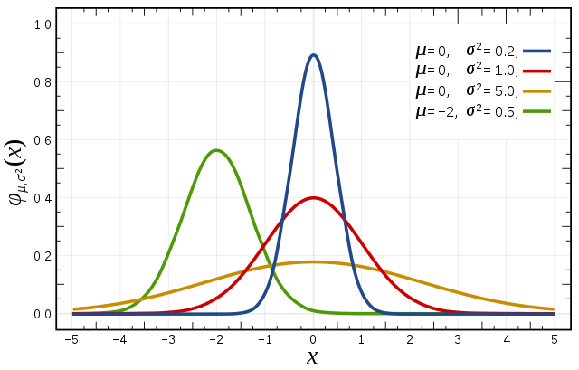
Slide 5: Example: Exponential Distribution
- The exponential distribution describes the time between events in a Poisson process.
- It is commonly used in reliability engineering and queuing theory.
- 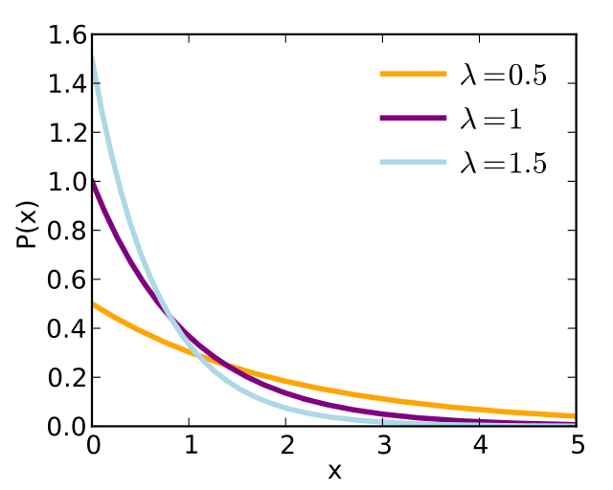
Slide 6: Long-tailed Probability Distributions
- Long-tailed distributions have slower decaying tails, meaning there is a higher probability of extreme events occurring.
- They are often associated with rare but impactful events.
- Examples include the Pareto distribution and the power-law distribution.
Slide 7: Example: Pareto Distribution
- The Pareto distribution is often used to model wealth distribution, where a small percentage of the population holds a large percentage of the wealth.
- It exhibits a heavy tail, indicating a higher probability of extreme outcomes.

Slide 8: Example: Power-law Distribution
- The power-law distribution describes a relationship between two quantities, where one varies as a power of the other.
- It is prevalent in various fields such as economics, biology, and network theory.

Slide 9: Heavy-tailed Distributions
- A heavy-tailed distribution refers to a distribution with tails that decay more slowly than the exponential distribution.
- These distributions have a higher likelihood of extreme events compared to short-tailed distributions.
- Heavy-tailed distributions are often associated with phenomena such as financial market fluctuations and network traffic.
Slide 10: Conclusion
- Short-tailed and long-tailed probability distributions represent different patterns of variability in data.
- Understanding these distributions is crucial for various fields including finance, risk management,
- and data analysis.
- Thank you for your attention. Are there any questions?
Slide 11: References
- Include citations and links to sources used in the presentation.

